SEXUAL ABUSE OF MINORS
BY SOME CLERICS INCARDINATED TO POLISH DIOCESES
AND MEMBERS PROFESSED BY PERPETUAL VOWS OF MALE RELIGIOUS ORDERS
AND ASSOCIATIONS OF APOSTOLIC LIFE IN POLAND

-THE RESULTS OF THE QUERY -

Warsaw 2019

Instrument development and substantive consultation:
Fr. Adam Żak SJ, PhD
Records, creating databases and data validation:
Fr. Przemysław Krakowczyk SAC, PhD
Consultation of the instrument, data analysis and preparation of results:
Fr. Wojciech Sadłoń SAC, PhD

The study contains the results of the data collected by the Secretariat of the Polish Bishops’ Conference and the Secretariat of the Conference of Major Superiors of Men.
The Institute for Catholic Church Statistics SAC named after Witold Zdaniewicz is the first in Poland, an independent center of research on religiosity and pastoral activity. It was founded in 1972 by the Association of the Catholic Apostolate (Pallottine Fathers).

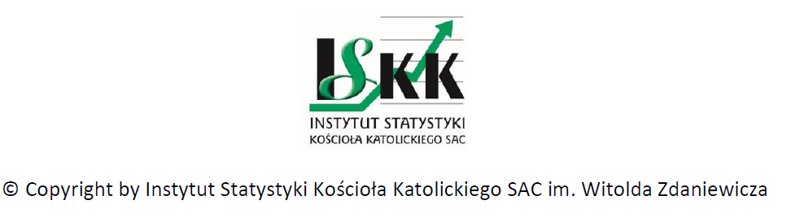

Table of contents

Preface ………………………………………………………………………………………. 4
The methodology of conducting the query ………………………………… 5
Query results …………………………………..…………………………………………. 6
Total number of cases ………………………………………………………………… 6
Sources of information about cases ……………………………………………. 7
Canonical proceedings and before state authorities …………………… 8

Case characteristics according to the prohibited act ………………….. 9

Basic methodological conclusions ……………………………………………… 11

Preface
The reference point of the conducted query are first of all the documents of the Catholic Church, such as the norms of Motu Proprio "Sacramentorum Sanctitatis Tutela" [The Defence of the Holiness of the Sacraments] promulgating the "Normae de graviorus delictis" [Norms concerning the heaviest criminal offenses] and "Guidelines for the preliminary canonical investigation in the case of accusations against a cleric for the transgression of the Decalogue’s sixth commandment with a minor under age eighteen" adopted by the Polish Bishops' Conference.

The methodology of conducting the query
The query concerned all clerics (who were ordained priests and deacons), who in the period from January 1, 1990 to June 30, 2018 were incardinated to Polish dioceses and all members professed by perpetual vows of male religious orders and associations of apostolic life, which have their seats in Poland and belong to the Conference of Major Superiors of Men. In addition to 41 territorial dioceses, also the Military Ordinariate of the Polish Army, two dioceses of the Byzantine rite and Armenian Ordinariate belong to the Polish Bishops' Conference, that is, 45 units, hereinafter referred to as "dioceses”. The Conference of Major Superiors of Men includes 59 units divided into 76 jurisdictions, hereinafter referred to as "orders". Among those, 74 jurisdictions were included in the query without Camaldolese and Chemin Neuf. The Little Brothers of Jesus do not belong to the Conference of Major Superiors of Men. Clerics of the personal prelature “Opus Dei” do not belong to the Polish Bishops’ Conference either. The clergy and religious brothers residing outside of Poland, but belonging to Polish dioceses and religious jurisdictions, were also included in the query.
The query concerned the cases of sexual abuse of minors submitted to Church institutions from January 1, 1990 to June 30, 2018. In other words, the query concerned the cases of an offence caused by a cleric or a religious person against the 6th commandment known to diocesan and religious curiae. Query results include cases of sexual abuse of minors until the age of 15 and from the age of 15 but until the age of 18, disclosed by dioceses and religious jurisdictions.
The query was carried out using paper forms sent through the Secretariat of the Polish Bishops’ Conference and the Conference of Major Superiors of Men. The forms consisted of two parts:
1. Statistical table on the quantification of the phenomenon studied in the Church unit
2. Cards about the characteristics of individual cases in a given unit.
Data on the period 1990-2013 was obtained by the Coordinator for the Protection of Children and Youth in 2014. All units included in the query provided data for the period from January 1, 2014 to June 30, 2018. While for the period of 1990-2013 only those that in 2014 did not provide such data. The Secretariat of the Polish Bishops’ Conference was responsible for monitoring and collecting the forms. Data collection lasted from October 2018 to March 2019.

Query results
Total number of cases
All reported cases of sexual abuse of minors (until the age of 18) in all dioceses and orders from January 1, 1990 to June 30, 2018, were 382, including those concerning minors under the age of 15 - 198 (51.8%) and above the age of 15 - 184 (48.2%).
Table 1. The total number of reported cases according to the year of reporting and the age of the victim
Sexual abuse Number % 1990-2013 2014 2015 2016 2017 2018*
Total 382 100,0 199 30 37 35 45 36
Cases under 15 198 51,8 111 18 18 16 17 18
Cases above 15 184 48,2 88 12 19 19 28 18
*until June 31, 2018.
There were 284 reported cases in the dioceses, including those concerning minors under the age of 15 - 154 (54.2%) and above the age of 15 - 130 (45.8%). Reported cases in male orders were 98, including those concerning minors under the age of 15 - 44 (44.9%) and above the age of 15 - 54 (55.1%).
Table 2. The total number of reported cases according to the year of reporting and the age of the victim in dioceses

Sexual abuse Number % 1990-2013 2014 2015 2016 2017 2018*
Total in dioceses 284 100,0 141 20 32 25 36 30
Cases under 15 154 54,2 85 13 14 11 15 16
Cases above 15 130 45,8 56 7 18 14 21 14
*until June 31, 2018.

Table 3. The total number of reported cases according to the year of reporting and the age of the victim in orders

Sexual abuse Number % 1990-2013 2014 2015 2016 2017 2018*
Total in orders 98 100,0 58 10 5 10 9 6
Cases under 15 44 44,9 26 5 4 5 2 2
Cases above 15 54 55,1 32 5 1 5 7 4
*until June 31, 2018.
The number of cases reported to Church units in particular years, from 1990 to June 2018 is depicted below.

Chart 1: Reported cases according to the year of reporting

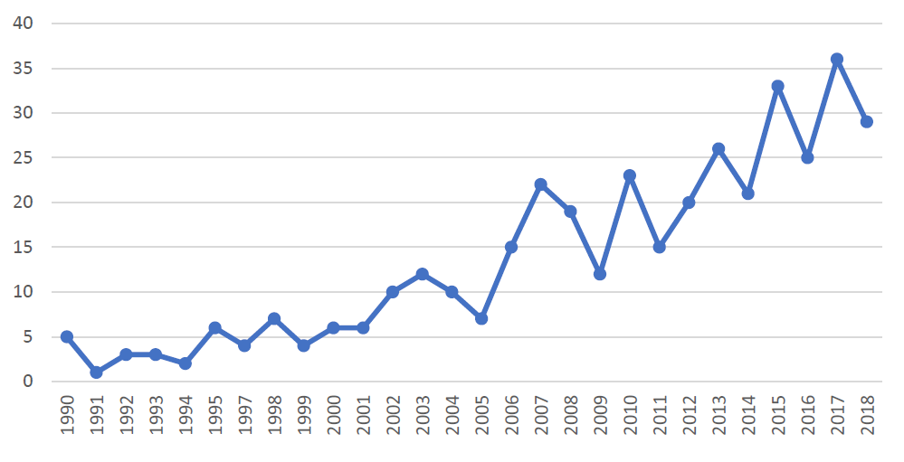
Sources of information about cases

The cases were reported to the Church units mostly by victims (41.6%) or their relatives (20.9%). In 5.8% the Church units learned about cases from State authorities, in 5.2% from the media. Parish people, that is, both clerics from parishes and lay people, reported 5.2% of cases. 1.3% of cases were reported by superiors (these cases concern religious). Knowledge about 14.9% of cases came from another source, such as: school head, pedagogue, educators, children’s caretakers and victims’ friends, confreres (in orders), seminarians, other priests.

Tab.4. Sources of reporting cases to Church units

Source of reporting Number %

Total of cases 382 100
Victim / victims 159 41,6%
Relatives of the victim 80 20,9
State authorities 22 5,8
Media 20 5,2
Parish people 20 5,2
Defendant himself 15 3,9
Superior (orders) 5 1,3
Others 57 14,9
No data 4% 1,0

Canonical proceedings and before State authorities

Among all the cases, in which the state of the canonical process was identified (94.8% of all reported cases), 74.6% of cases were already completed, while 25.4% of them were still pending cases*. The cases completed with dismissal from the clerical state represented 25.2%; other penalties (suspense, canonical admonition, prohibition on work with minors, removal from office, restriction of ministry or prohibition on public appearances) represented 40.3%; the cases completed with other consequences (imposition of penance, transfer to another parish, transfer outside a parish pastoral work to a retirement home or to a home for sick priests, therapy, arbitrary abandonment of the diocese) accounted for 11.5%, while the cases completed with a dismissal of proceedings (due to the death of the accused person, suicide or lack of sufficient evidence, poor health) accounted for 12.6%; in 10.4% of cases, the proceedings ended with the acquittal of the defendant.

* A high percentage of pending cases is due to the fact that some of the analysed data came from the query carried out in 2014, that is, it contained information on canonical proceedings and before State authorities according to the state of 2014.

Tab.5. Reported cases according to canonical proceedings

Canonical proceeding Number %
Total 382 100,0
Canonical proceeding 362 94,8
No data 20 5,2
Among canonically proceeded cases
Total 362 100,0
Completed canonical proceedings 270 74,6
Pending proceedings 92 25,4
Among completed canonical proceedings
Total 270 100,0
Dismissal from the clerical state 68 25,2
Other penalties 109 40,3
Other consequences 31 11,5
Dismissal of the case 34 12,6
Acquittal 28 10,4

From the information provided, it appears that from 1990 to 2018 among all cases reported to Church units regarding both victims under and above the age of 15, proceedings before State authorities were 44.0%. Pending cases proceeded before State authorities, at the date of data collection, were 19.6%*, while completed proceedings were 80.4%. Among completed cases in the proceeding before State authorities, 63.0% of cases ended with a conviction (including compensation awarded to the victim in 5.9% of cases); 26.6% with a dismissal of proceeding; 8.9% with a refusal to initiate proceedings and 1.5% with an acquittal.

Tab.6. Reported cases according to the proceedings before State authorities

Proceedings before State authorities Numbers %
Total 382 100,0
Proceedings before State authorities 168 44,0
No reporting 120 31,4
No data 94 24,6
Among cases proceeded before State authorities
Total 168 100
Completed 135 80,4
Pending proceedings 33 19,6
Among completed in proceeding
Total 135 100
Conviction 85 63,0
Dismissal of proceedings 36 26,6
Acquittal 2 1,5
Dismissal of proceeding 12 8,9

Case characteristics according to the prohibited act

Reported cases, including those in which defendants in the canonical process were found innocent, were much less likely to refer to the years before 1980. Definitely more cases concern alleged acts in recent decades, as shown in the chart below.

Chart 2: Cases according to the year of committing the alleged act*

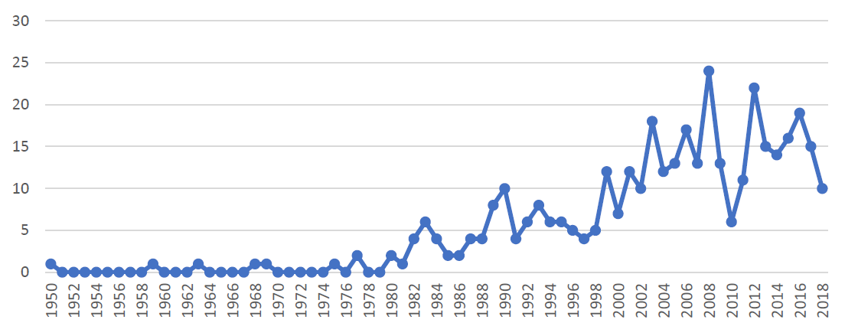

* - in cases which concerned alleged acts occurring not only within one year, only the first year was taken into account.

In dioceses (not including 7 cases where the number of victims was referred to as "several" and 8 cases of child pornography), the total number of victims under the age of 15 in all reported cases (also unconfirmed) in 1990-2018 was 254. In orders, excluding 2 cases, where the number was identified as several, 1 case of pornography and 2 cases with missing data, the total number of victims in all reported cases under the age of 15 was 91. Thus, in both dioceses and orders (excluding the above-mentioned cases, in which the number of victims could not be identified unambiguously) the number of victims in all (also unconfirmed) cases under the age of 15 was 345.

In dioceses (not including 2 cases where the number of victims was defined as "several"), the total number of victims above the age of 15 in all reported cases in 1990-2018 was 192. In orders, not including 2 cases in which the number was referred to as several, the total number of victims in all reported cases above the age of 15 was 88. Thus, the number of victims in all cases (except for the 4 aforementioned cases where the number of victims was not clearly defined) above the age of 15 in dioceses and orders (also unconfirmed) was 280.

Among the victims, in all reported cases, male minors in total accounted for 58.4%, while the female minors - 41.6%.

Basic methodological conclusions

Between dioceses and religious jurisdictions there were differences in the reliability of completed surveys. The data provided by the dioceses and religious jurisdictions in a few cases were incomplete and inconsistent, which required additional monitoring and verification of data. In some cases, the age of the victims could not be unambiguously determined. In such individual cases, at the stage of data verification, the age of victims was defined as lower. Answers to open questions in card forms indicated some ignorance regarding possible and required in Church regulations approaches to reported cases. Taking into account possible further research, it is proposed to reformulate open questions into closed and semi-closed questions in accordance with the following principles:

1. Divide the question about the canonical process and further proceedings into:
a. procedures of the canonical process
b. temporary remedies for the duration of the process
c. the effects of the trial (acquittal, dismissal, conviction - what kind of punishment?)

2. The question about the criminal process before State authorities should be categorized according to the answer: no report, refusal to initiate proceedings, dismissal, acquittal (in each category why?), conviction (with suspended sentence, custodial sentence, awarding compensation, pending case)

3. Consider the civil lawsuit question with categorized answers: judgment awarding (compensation, other - what?), judgment dismissing the claim, dismissal of the proceedings, pending case, lack of notification. A question about the plaintiff in a civil suit: a suspected cleric, a presumed victim, others - what?

